Ayonna Jones

Professor Michael Spivey

COGS 104

3 March 2020

Assmt #4:

Part A) Aggregation Causes a Normal Distribution to Emerge from a Flat Distribution

clear

x=rand(1,2000);

mean(x);

subplot(1,3,1);%1 row and 3 columns

histogram(x);

axis([0 1 0 600])

y=rand(1,2000);

z=[x;y]; %semicolon makes a new row this is now a 2000 by 2000 matrix

agg1=mean(z);

subplot(1,3,2);

histogram(agg1,10);

axis([0 1 0 600]); %x axis and y axis

agg2=mean(rand(30,2000));

subplot(1,3,3); %dont forget the subplot

histogram(agg2);%histogram of agg2

axis([0 1 0 200]);

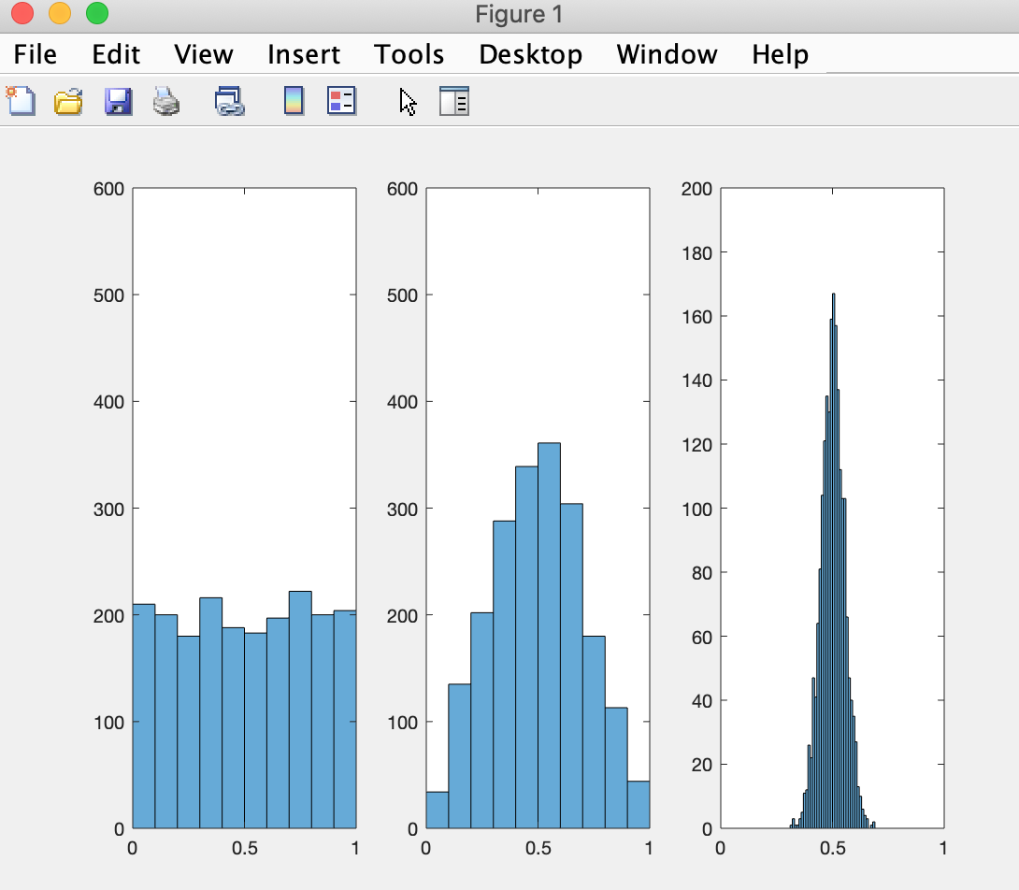

Part B) Aggregation Causes A Normal Distribution to Emerge from a Bimodal Distribution

clear

x1=rand(1,1000)\*0.4;

x2=0.6+rand(1,1000)\*0.4;

x=[x1 x2];

randx=x(randperm(2000));

for t=1:30

y1=rand(1,1000)\*0.4;

y2=0.6+rand(1,1000)\*0.4;

y=[y1 y2];

randy=y(randperm(2000));

alloutputs(t,:)=randy;

end

subplot(1,3,1);

histogram(alloutputs);

axis([0 1.05 0 3000]);

subplot(1,3,2)

histogram(mean(alloutputs(1:2,:)));

subplot(1,3,3)

histogram(mean(alloutputs));

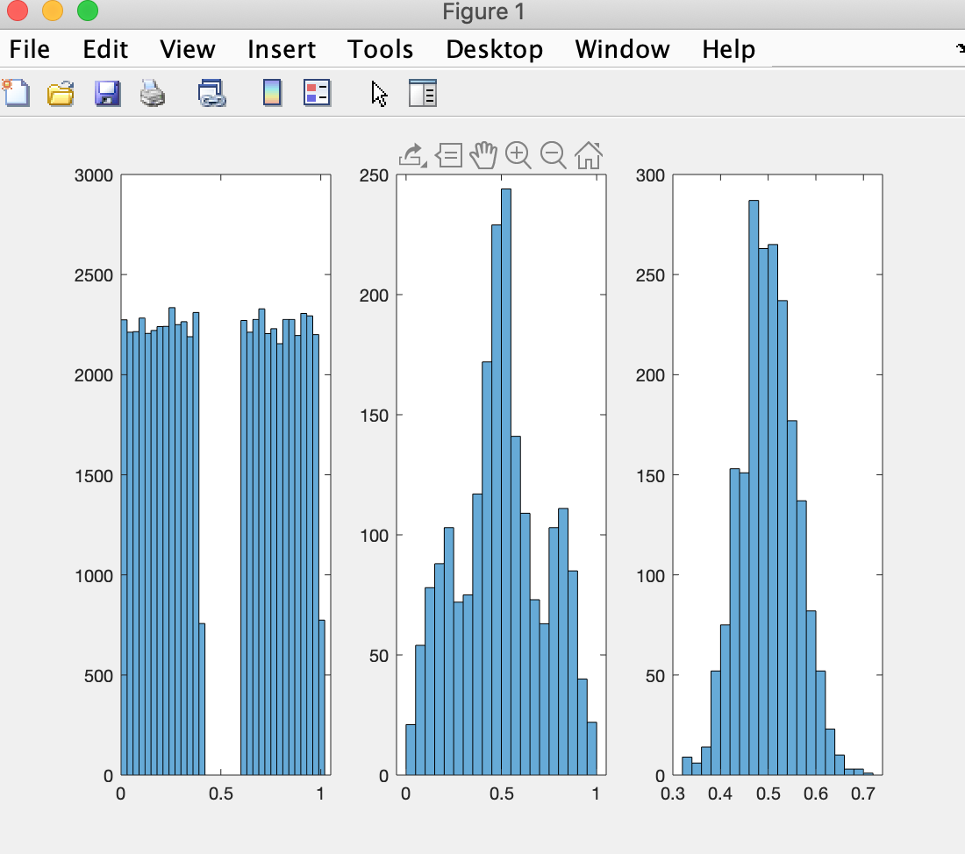

Part C) Aggregation Causes A Normal Distribution to Emerge from a CRAZY Distribution

clear

all=[];

for i=1:30

data=[rand(1,1000)\*.7 rand(1,1000)\*.7+.3];

data=data(randperm(2000));

all=[all; data];

end

subplot(1,3,1)

histogram(all(1,:))

subplot(1,3,2)

histogram(mean(all(1:2,:)))

subplot(1,3,3)

histogram(mean(all))

